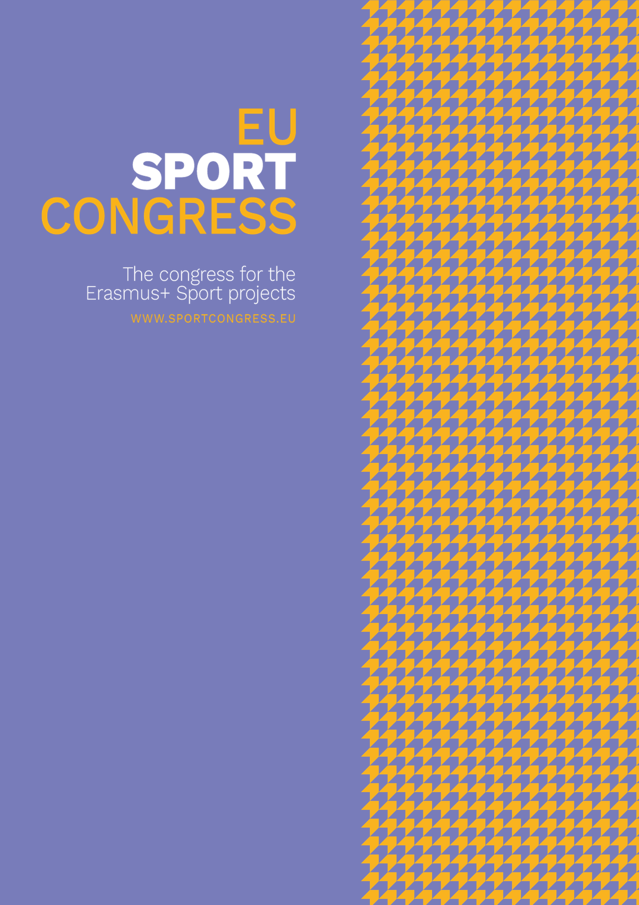

CALL FOR HOSTS
Licensing & Hosting Bid Application
Next Edition — Host Selection Process
Issued by the Secretariat of the European Sport Congress
secretariat@sportcongress.eu · sportcongress.eu
This document is confidential and intended solely for prospective host organisations.

Annex I — Bid Application Form
Please complete the table below and return it together with any supporting materials referenced in Section 9.
Field | Applicant to complete
Organisation / consortium name
Type of organisation
Legal representative & position
Contact email & phone
Proposed host city
Proposed venue
Proposed dates
Estimated onsite participants
Estimated online participants
Proposed themes
Added value / differentiators
Consortium partners (if any)
Supporting materials attached

Declaration
By submitting this application, the undersigned organisation confirms it has read, understood, and agrees in principle to be bound by the terms outlined in this Call for Hosts, subject to the final terms of the Hosting Agreement.

Organisation name: _______________________________________________
Legal representative: _______________________________________________

Date and city

Signature: _______________________

